Report
Of

ARTIFICIAL INTELLIGENCE AND MACHINE LEARNING

Submitted
To
School of Computer Science and Engineering
IILM University, Greater Noida, U.P.

In partial fulfilment of the requirement of degree of
B.Tech CSE



By
Roll Number of Student: 2410031179
Name of Student: TANISHQ
Batch: 2024-2028

2026-27

CANDIDATE’S DECLARATION

I, Tanishq do hereby declare that the internship report titled “Artificial Intelligence and Machine Learning” has been completed by me to fulfil the requirement for the award of the degree of Bachelor of Technology in Computer Science and Engineering.
This report is based on the knowledge, learning activities, technical concepts, and practical exposure gained during my internship in the domain of Artificial Intelligence and Machine Learning. All the references and learning resources used in the preparation of this report have been appropriately acknowledged.
I further declare that this report is my original work and has not been submitted to any other institute or university for the award of any degree or diploma. I shall be solely responsible for any kind of copyright violation in this regard.

Signature
Student Name: Tanishq
Roll No. 2410031179

ACKNOWLEDGEMENT

I would like to express my sincere gratitude to everyone who supported and guided me throughout my Artificial Intelligence and Machine Learning Internship.
I am thankful to Kodacy Technologies and the AICTE Virtual Internship Programme for providing me with the opportunity to explore and learn various concepts related to Artificial Intelligence, Machine Learning, Deep Learning, Python programming, Neural Networks, and modern AI technologies.
The internship provided me with valuable exposure to both theoretical concepts and practical approaches in the field of Artificial Intelligence and Machine Learning. The structured learning experience helped me understand important topics such as machine learning algorithms, deep learning architectures, data analysis, model development, validation, and optimization.
I would also like to express my sincere gratitude to my faculty members and IILM University, Greater Noida, for their guidance and support. Finally, I am deeply thankful to my parents and everyone who encouraged me throughout this learning journey.

Signature
Student Name: Tanishq
Roll No. 2410031179

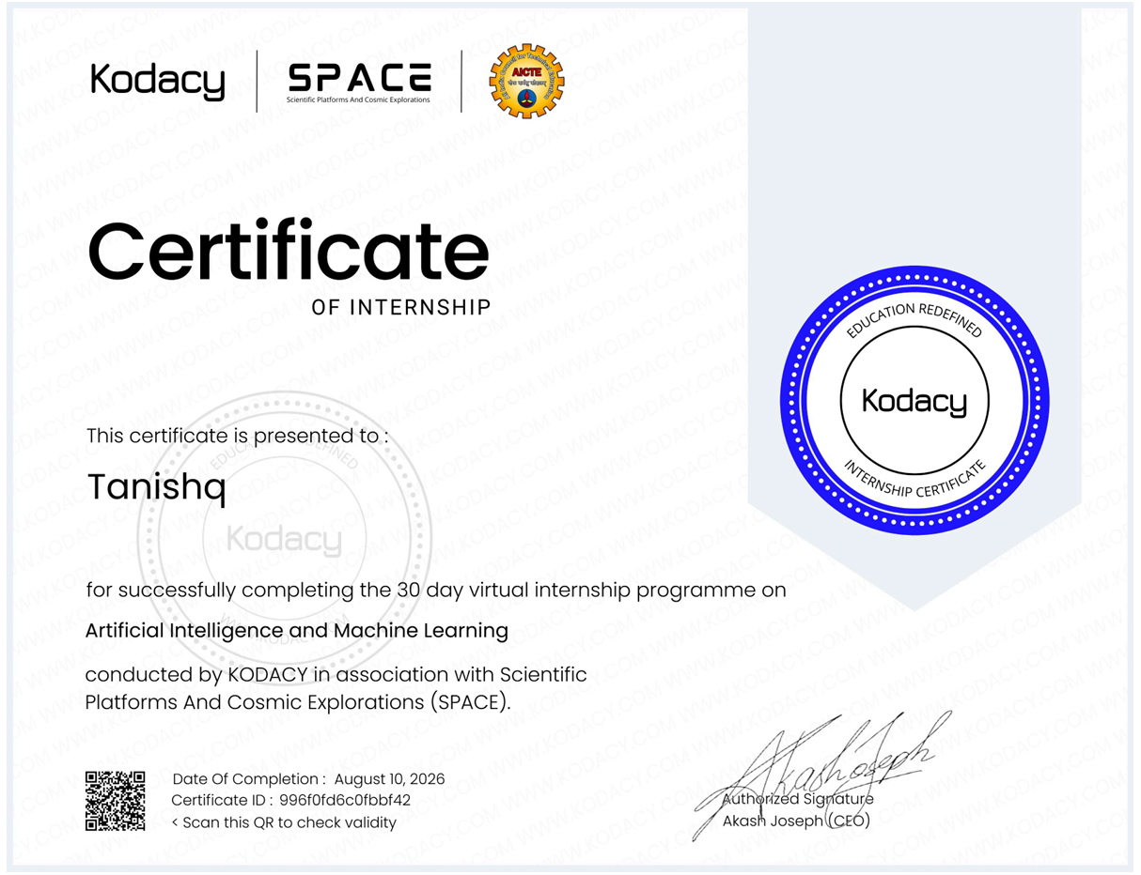

Chapter No. | Chapter Name | Page Nos.
 | Cover Page | ---
1. | Candidate’s Declaration | 2
2. | Acknowledgment | 3
3. | Internship Completion Certificate | 4
4. | Project Description  4 .1 Introduction  4.2 Organization Profile  4.3 Problem Statement  4.4 Project Objectives  4.5 Scope of the Project  4.6 Technologies and Tools Used  4.7 System Architecture  4.8 Methodology  4.9 Expected Outcomes  4.10 Certificates of completion and other communication mail proof must be attached | 6  7  8  9  10  12  13  15  17  19  20
5. | Bibliography/References | 21

4.PROJECT DESCRIPTION
The internship in Artificial Intelligence and Machine Learning was a valuable learning experience that helped me understand how intelligent systems and data-driven technologies work in practice. The internship covered important concepts from Artificial Intelligence, Machine Learning, Deep Learning, Python programming, and modern AI systems.
During the internship, I learned about the basic principles of Artificial Intelligence and how intelligent systems are designed to solve problems, analyse information, and support decision-making. The programme also introduced important Machine Learning concepts, including classification, regression, different learning algorithms, and model development techniques.
Another major part of the internship focused on Deep Learning and neural networks. I explored concepts such as perceptrons, activation functions, hidden layers, backpropagation, Convolutional Neural Networks (CNNs), and Recurrent Neural Networks (RNNs). These topics helped me understand how machines can learn complex patterns from different types of data.
The internship also provided exposure to Python programming and the general workflow followed while developing Machine Learning models. This included understanding data, preprocessing it, selecting suitable models, training them, validating their performance, and improving them through tuning and optimization.
Overall, the internship gave me a broader understanding of the Artificial Intelligence and Machine Learning domain. It helped me connect the concepts learned academically with the practical steps involved in developing AI and Machine Learning systems. The internship also introduced modern topics such as conversational AI, chatbots, and Large Language Models, which helped me understand the growing applications of AI in today's world.

4.1 INTRODUCTION
Artificial Intelligence and Machine Learning are among the most important and rapidly growing areas of Computer Science. Today, AI is being used in many applications that we interact with regularly, such as recommendation systems, voice assistants, image recognition, chatbots, and predictive systems.
Artificial Intelligence focuses on developing systems that can perform tasks involving reasoning, problem-solving, learning, and decision-making. Instead of simply following a fixed set of instructions, an intelligent system can use information and available data to produce meaningful results.
Machine Learning is an important part of Artificial Intelligence. It allows computer systems to learn patterns from data and use those patterns to make predictions or decisions. Depending on the type of problem, Machine Learning can be used for tasks such as classification and regression.
Deep Learning is a further extension of Machine Learning that uses multi-layered neural networks to learn more complex patterns. During the internship, I explored the basic structure of neural networks and concepts such as activation functions, hidden layers, and backpropagation. I was also introduced to architectures such as Convolutional Neural Networks, which are commonly associated with image and spatial data, and Recurrent Neural Networks, which are used for sequential and time-dependent data.
The internship helped me understand these topics in a structured manner, starting from the basic concepts of AI and gradually moving towards Machine Learning, Deep Learning, Python programming, model development, validation, and modern AI systems. This progression made it easier to understand how different areas of Artificial Intelligence are connected and how they contribute to the development of intelligent applications.

4.2 ORGANIZATION PROFILE
The internship was completed through the AICTE Virtual Internship Programme in association with Kodacy Technologies (Kodacy). The internship was focused on the domain of Artificial Intelligence and Machine Learning and provided a structured learning experience covering different concepts and technologies related to this field.
The programme covered several important areas, including Artificial Intelligence fundamentals, Machine Learning, Deep Learning, Python programming, neural networks, Computer Vision, model validation, and optimization. The learning process was organised in a structured manner, beginning with basic concepts and gradually moving towards more advanced topics.
Through the internship, I was able to explore how different areas of AI and Machine Learning are connected. The programme included both conceptual understanding and technical learning related to algorithms, data processing, neural networks, and Machine Learning workflows.
The virtual mode of the internship also made it possible to learn through structured modules and technical resources. Overall, the internship provided useful exposure to the AI and Machine Learning domain and helped me develop a better understanding of the technologies and processes involved in building intelligent systems.

4.3 PROBLEM STATEMENT
Artificial Intelligence and Machine Learning involve many different concepts and processes, and understanding how they work together can be challenging. Learning an individual algorithm or concept is useful, but it is equally important to understand the complete process involved in developing an intelligent system.
A typical Machine Learning system involves several stages. It starts with understanding the problem and working with data, followed by data preparation, feature representation, model selection, training, evaluation, and improvement. Without understanding this complete workflow, it can be difficult to see how theoretical concepts are applied in practical situations.
Another challenge is connecting the concepts of Artificial Intelligence with real technical workflows. Topics such as search and reasoning, probabilistic modelling, classification, regression, neural networks, and optimization are often studied separately. However, understanding their role in intelligent systems requires a broader and more structured learning approach.
Therefore, the main focus of this internship was to develop a clear understanding of the important concepts of Artificial Intelligence and Machine Learning and to explore the different stages involved in the development and evaluation of intelligent models.
The internship provided learning exposure to AI fundamentals, Machine Learning algorithms, Deep Learning architectures, Python programming, model validation, optimization, data handling, and modern AI systems. This helped in building a more organised understanding of the overall AI and Machine Learning domain.

4.4 PROJECT OBJECTIVES
The main objective of this internship was to develop a strong understanding of the fundamental and practical concepts of Artificial Intelligence and Machine Learning.
The specific objectives of the internship were:
- To understand the basic concepts, principles, and applications of Artificial Intelligence.
- To learn how intelligent systems can be used for reasoning, problem-solving, and decision-making.
- To understand the fundamental concepts of Machine Learning, including classification and regression.
- To explore how Machine Learning algorithms learn patterns from data and use those patterns to make predictions.
- To gain knowledge of Deep Learning and Artificial Neural Networks.
- To understand concepts such as perceptrons, activation functions, hidden layers, and backpropagation.
- To explore Deep Learning architectures such as Convolutional Neural Networks and Recurrent Neural Networks.
- To develop familiarity with Python programming concepts used in Artificial Intelligence and Machine Learning.
- To understand the different stages involved in the Machine Learning model development lifecycle.
- To learn about model validation, performance evaluation, hyperparameter tuning, and optimization.
- To explore modern developments in Artificial Intelligence, including conversational systems and Large Language Models.
These objectives helped provide a structured learning path throughout the internship, starting with the fundamentals and gradually moving towards more advanced AI and Machine Learning concepts.

4.5 SCOPE OF THE INTERNSHIP
The scope of the internship covered a broad range of topics related to Artificial Intelligence and Machine Learning. The programme was not limited to a single algorithm or technology; instead, it introduced different areas that are important for understanding modern intelligent systems.
The internship began with the fundamentals of Artificial Intelligence. This included concepts related to reasoning, search techniques, knowledge representation, and intelligent problem-solving. These topics provided a foundation for understanding how AI systems approach and solve different types of problems.
The Machine Learning section covered important concepts such as classification and regression. Different algorithms and approaches, including Decision Trees, Random Forests, Gradient Boosting, and XGBoost, were also introduced as part of the learning process.
The scope of the internship also included Deep Learning and neural networks. Concepts such as perceptrons, activation functions, hidden layers, backpropagation, CNNs, RNNs, and Generative Adversarial Networks were explored to understand how deep neural networks can be used with different types of data.
Python programming was another important part of the internship. The programme covered programming concepts and data structures that are useful when working with Artificial Intelligence and Machine Learning systems.
The internship further covered the general Machine Learning workflow, including data exploration, preprocessing, model selection, training, validation, tuning, and optimization. Modern AI topics related to chatbots, conversational systems, and Large Language Models were also included.
Overall, the internship provided a broad introduction to the different areas of AI and Machine Learning and helped in understanding how these areas are connected.
4.6 TECHNOLOGIES AND TOOLS USED
During the internship, I explored different technologies, programming concepts, and Machine Learning approaches related to Artificial Intelligence and Machine Learning.
Python Programming
Python was one of the important programming foundations covered during the internship. I explored concepts related to data structures, control flow, functions, and modular programming. These concepts are important for writing and understanding programs used in AI and Machine Learning.
Machine Learning Algorithms
The internship introduced different Machine Learning approaches and algorithms. These included classification and regression, along with algorithms such as K-Nearest Neighbours, Logistic Regression, Decision Trees, Random Forests, Gradient Boosting, and XGBoost.
Deep Learning
Deep Learning concepts formed an important part of the programme. The topics included Artificial Neural Networks, perceptrons, activation functions, hidden layers, and backpropagation. The internship also introduced advanced architectures such as Convolutional Neural Networks, Recurrent Neural Networks, and Generative Adversarial Networks.
Model Development and Validation
The Machine Learning model development process included different stages such as Exploratory Data Analysis, data cleaning, preprocessing, model selection, training, validation, hyperparameter tuning, and optimization.
Data Handling and Pipelines
The internship also covered concepts related to missing value handling, categorical data encoding, Machine Learning pipelines, prevention of data leakage, and cross-validation.
These technologies and concepts helped me understand the technical workflow involved in developing and evaluating Machine Learning models
.

4.7 SYSTEM ARCHITECTURE

The internship covered the general workflow followed while developing an Artificial Intelligence and Machine Learning system. Although different AI applications may use different algorithms and techniques, the overall development process generally follows a structured sequence.
The process begins with understanding and defining the problem. Once the problem is clearly identified, relevant data is collected or selected for further analysis. The data is then explored to understand its structure, quality, and important patterns.
After the initial analysis, the data is prepared through preprocessing and cleaning. This stage may involve handling missing values, converting data into a suitable format, and preparing features that can be used by a Machine Learning model.
The next stage involves selecting an appropriate model according to the type of problem. The selected model is trained using the prepared data and its performance is then evaluated through suitable validation techniques.
Based on the evaluation results, the model can be improved through hyperparameter tuning and optimization. Once the required performance is achieved, the model can be used to generate predictions, classifications, or other intelligent outputs.
The overall workflow can be represented as follows:

This architecture helped me understand that developing a Machine Learning system is not limited to simply selecting and training an algorithm. Each stage of the process contributes to the overall performance and reliability of the final model.

4.8 METHODOLOGY

The internship followed a structured learning approach in which the topics progressed from the fundamental concepts of Artificial Intelligence towards Machine Learning, Deep Learning, model development, and modern AI technologies.
The methodology followed during the internship can be described through the following stages:

Step 1: Understanding Artificial Intelligence Fundamentals
The internship began with the basic concepts of Artificial Intelligence. This included understanding how intelligent systems approach problems through reasoning, search techniques, and knowledge representation.

Step 2: Exploring Machine Learning Concepts
The next stage focused on Machine Learning and the role of data in building intelligent systems. Concepts such as classification and regression were explored to understand how models can identify patterns and make predictions.
Different Machine Learning approaches and algorithms were also introduced as part of this stage.

Step 3: Understanding Deep Learning
The internship then introduced Deep Learning and Artificial Neural Networks. I learned about the basic components of neural networks, including perceptrons, activation functions, hidden layers, and backpropagation.
The programme also introduced architectures such as Convolutional Neural Networks and Recurrent Neural Networks to understand how Deep Learning can be applied to different types of data.

Step 4: Developing Python Programming Knowledge
Python programming concepts were explored as part of the technical foundation for Artificial Intelligence and Machine Learning. This included understanding programming structures, control flow, functions, and data-related programming concepts.

Step 5: Understanding Data and Preprocessing
The next stage focused on understanding the importance of data in Machine Learning. Concepts related to data exploration, preprocessing, and preparing data for model development were covered.
This stage also introduced the importance of handling data carefully before using it for training a Machine Learning model.

Step 6: Model Selection and Training
Once the data and problem were understood, the next stage involved learning about model selection and training. Different algorithms can be suitable for different types of problems, so understanding the problem and available data is important before selecting a model.
The selected model is then trained using the prepared data to learn patterns and relationships.

Step 7: Model Validation and Evaluation
After training, the performance of the model needs to be evaluated. The internship introduced concepts related to model validation and performance evaluation to understand how well a model can perform beyond the data used during training.

Step 8: Hyperparameter Tuning and Optimization
The next stage involved understanding how model performance can be improved through hyperparameter tuning and optimization. This process helps in identifying suitable settings for improving the effectiveness and reliability of a Machine Learning model.

Step 9: Understanding Data Integrity and Reliable Workflows
The internship also covered concepts related to proper data handling, Machine Learning pipelines, cross-validation, and the prevention of data leakage. These concepts are important for developing reliable and properly evaluated Machine Learning models.

Step 10: Exploring Modern Artificial Intelligence
The final part of the internship introduced modern developments in Artificial Intelligence, including conversational AI, chatbots, and Large Language Models.
This structured methodology made it easier to understand how the different areas of Artificial Intelligence and Machine Learning are connected. The internship progressed from basic concepts towards more advanced topics and practical workflows involved in developing intelligent systems.

4.9 EXPECTED OUTCOMES

The internship helped in developing a broader understanding of the concepts and technologies used in the field of Artificial Intelligence and Machine Learning.
One of the main outcomes was a better understanding of the relationship between Artificial Intelligence, Machine Learning, and Deep Learning. The internship helped me understand how these areas are connected and how they can be used to develop systems capable of analysing data and performing intelligent tasks.
Through the internship, I developed familiarity with important Machine Learning concepts such as classification, regression, model selection, training, and evaluation. I also gained an understanding of how Machine Learning models learn patterns from data and how their performance can be improved through validation and optimization.
Another important outcome was exposure to Deep Learning concepts and neural networks. Topics such as perceptrons, activation functions, hidden layers, backpropagation, CNNs, and RNNs provided a foundation for understanding how deep neural networks are structured and used.
The internship also strengthened my understanding of Python programming concepts and their importance in Artificial Intelligence and Machine Learning.
The overall learning experience also helped me understand the complete Machine Learning workflow, including data exploration, preprocessing, model selection, training, validation, tuning, and optimization.
The major learning outcomes of the internship can be summarised as follows:
- Improved understanding of Artificial Intelligence fundamentals.
- Knowledge of basic Machine Learning concepts and algorithms.
- Understanding of classification and regression problems.
- Exposure to different Machine Learning approaches and ensemble methods.
- Basic understanding of Artificial Neural Networks and Deep Learning.
- Knowledge of concepts such as activation functions and backpropagation.
- Exposure to CNNs and RNNs.
- Improved familiarity with Python programming concepts.
- Understanding of the Machine Learning model development workflow.
- Knowledge of model validation and performance evaluation.
- Understanding of hyperparameter tuning and optimization.
- Awareness of modern Artificial Intelligence technologies such as conversational AI and Large Language Models.
Overall, the internship provided a strong foundation for further learning and practical exploration in the field of Artificial Intelligence and Machine Learning.

4.10 CERTIFICATE OF COMPLETION AND OTHER SUPPORTING DOCUMENT

The Internship Completion Certificate received after completing the Artificial Intelligence and Machine Learning Internship is attached to this report as supporting documentation.
The certificate serves as evidence of my participation and completion of the internship programme.

5. BIBLIOGRAPHY / REFERENCES

- AICTE Virtual Internship Programme. Internship learning materials and technical modules related to Artificial Intelligence and Machine Learning.
- Kodacy Technologies (Kodacy). Internship learning resources and programme materials related to Artificial Intelligence and Machine Learning.
- Python Software Foundation. Python Documentation.
- Scikit-learn Developers. Scikit-learn: Machine Learning in Python Documentation.
- TensorFlow. TensorFlow Documentation.
- Goodfellow, I., Bengio, Y., and Courville, A. Deep Learning. MIT Press.
- Russell, S. and Norvig, P. Artificial Intelligence: A Modern Approac

